Andrew Stites

EEE 64 – CpE64 Section 2

Wednesday

Lab 3-5

Samuel Wekanda

Lab Objective/Goal: Utilize Multisim and an actual bread board to show a simple circuit with just switches and LED’s. Then, use the AND, OR, INVERTER, and NAND logic gates in conjunction with the switches and LED’s in Multisim and on the actual bread board. Finally, record and present the truth tables of the actual, simulated, and predicted results.

Lab Preparations and Challenges:

I opened the provided file for Multisim and flipped the first two switches on the virtual DIP Switch. The first two LED’s on the LED Bar lit up in conjunction with the switches either being High or Low--1 or 0. I moved on to the logic gates starting with the AND gate connected to the same switches as before for the two inputs and then the output leading to the farthest pin on the LED Bar. When both switches were High, the last LED would light. All other configurations of the switches yielded a Low output. Next, I hooked up the OR gate with the inputs attached to the same switches and the output connected to the last LED on the LED Bar. All combinations of switch positions yielded a High output except when both switches were Low or off. Subsequently, I connected the NAND gate to the same switches with the inputs and and the output to the last LED on the LED Bar. As the name suggests, this is the reciprocal of the AND gate. So, it exhibited all the opposite results of the AND gate which were having all the switch combinations be High except when both switches were High. Last, I setup the INVERTER to only one switch due to it being the negating logic gate with only two outputs to be recorded. When the switch was High, the output was Low and vice-versa. I placed all the gates on the switches and connected each output to a pin on the LED Bar. All gates were spot on worked exactly as if they were solo.

On the actual bread board, I used the TC4081BP logic chip for the AND gate. When the circuit was completed with 330 Ohms resistors on the red LED’s and 1k Ohms connected to the switches from the positive rail, the actual AND gate emulated the virtual simulation on Multisim. The SN74LS32N logic chip for the OR gate followed suit with the same resistor setup for the LED’s and switches. It too portrayed the same results as the virtual simulation in Multisim. The setup stayed the same only the OR gate was replaced with the CD4011BP logic chip for the NAND gate. It showed the opposite results as the AND gate and mimicked the virtual simulation in Multisim. The SN74LS04N logic chip for the INVERTER was saved for last due to having just one switch wired into the gate and out to one LED. The results were exact to the virtual simulation in Multisim. After what felt like a lifetime, I setup the bread board with all the logic gates and 6 LED’s to show the output of the gates. The result was exact as the Multisim simulation with all inputs leading to the correct outputs respective of the logic gate.

Lab Results:

**Basic Circuit:**

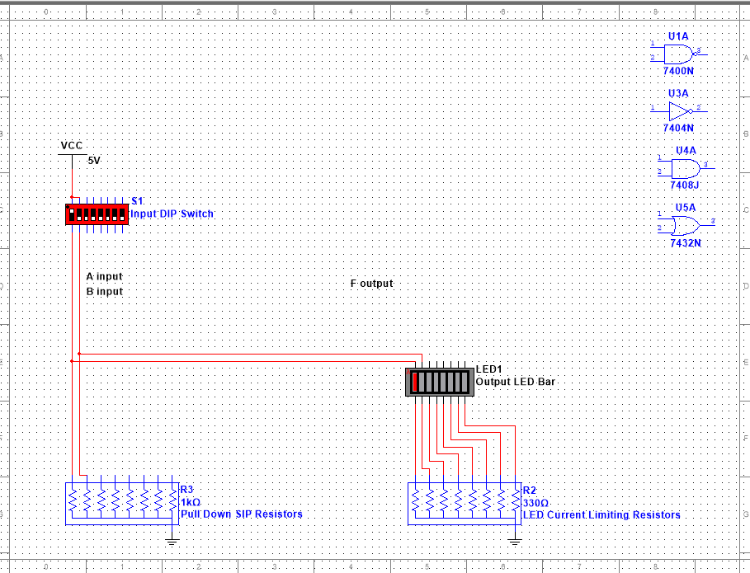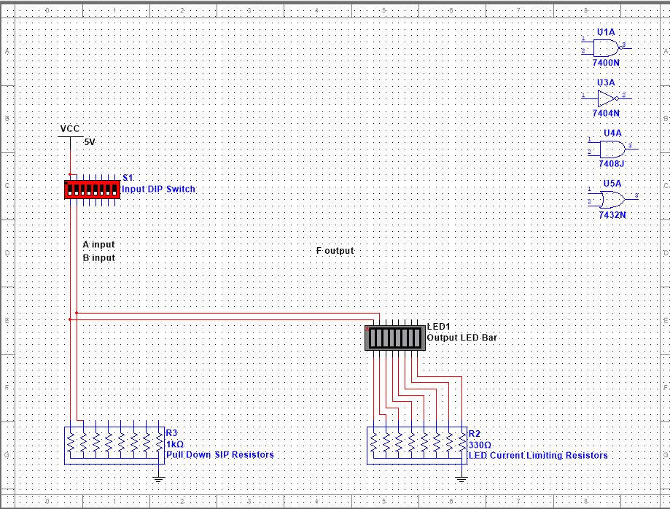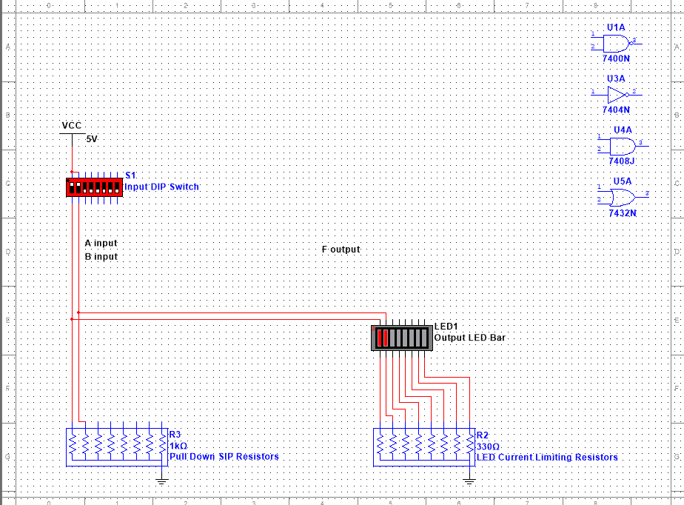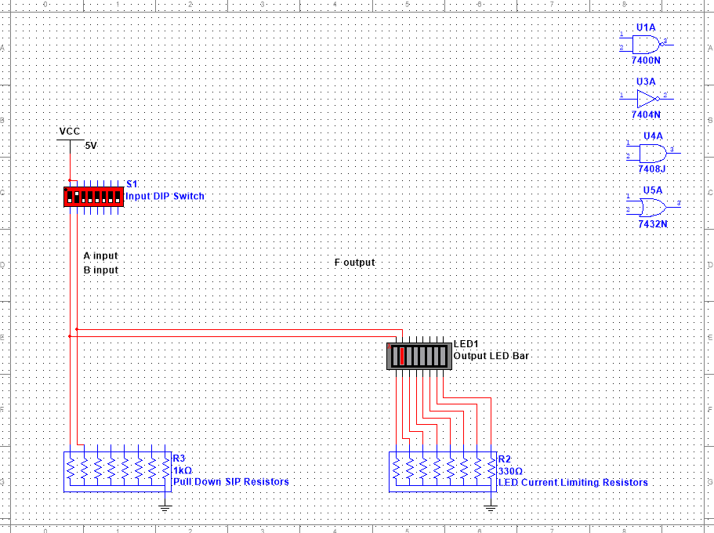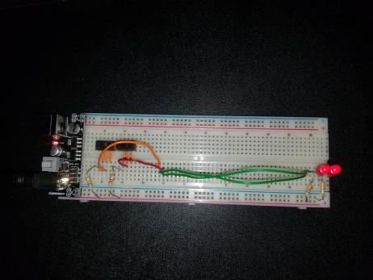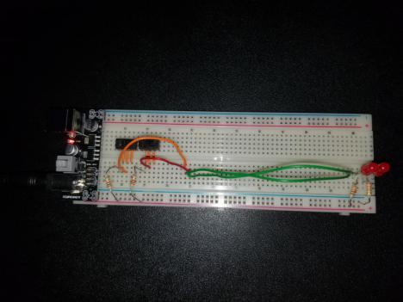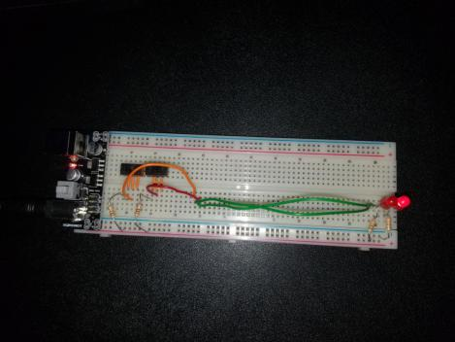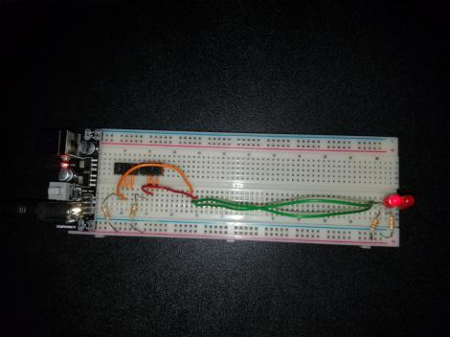

This is the basic circuit that has two switches with a 1k Ohms resistors connected to each and to ground, a power supply with 5v being used, two red LED’s connected to ground with two 330 Ohms resistors.

**AND Gate Circuit:**

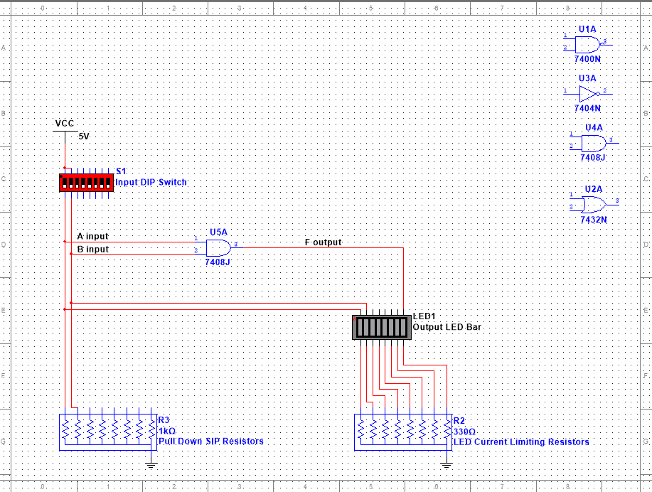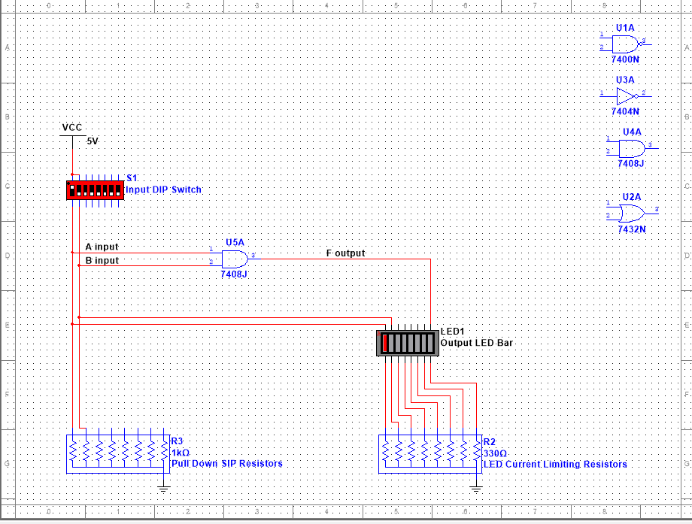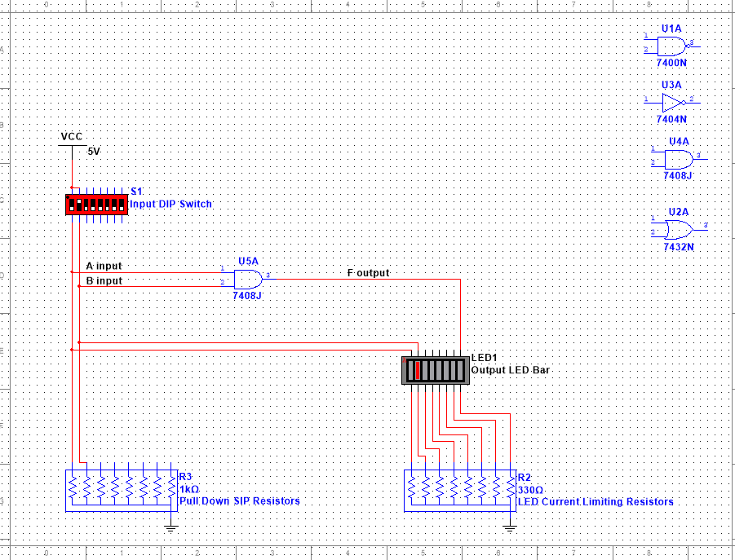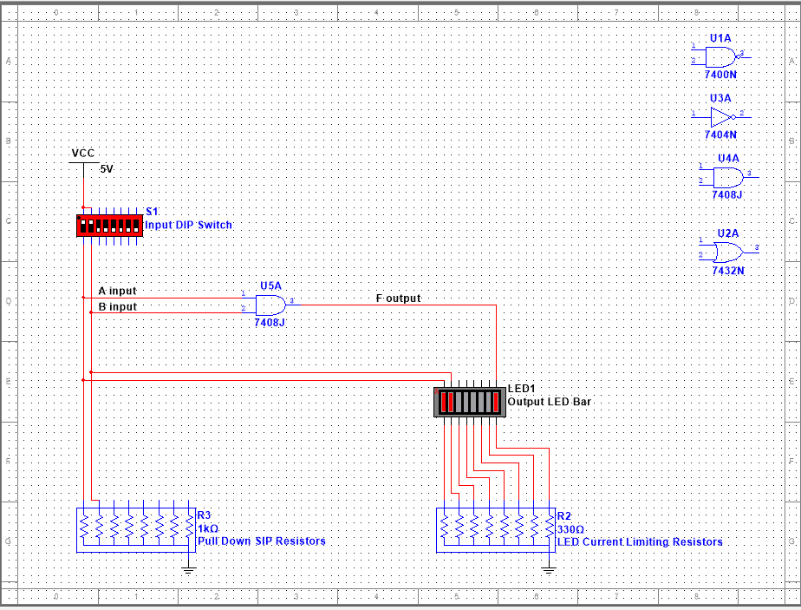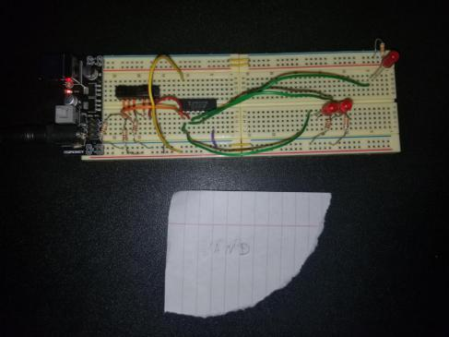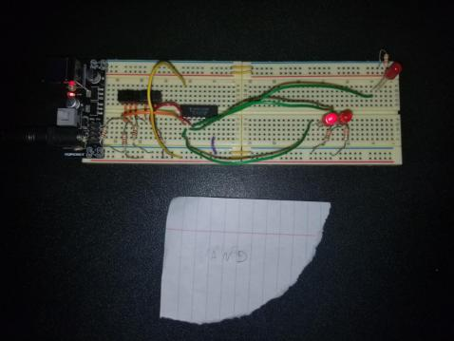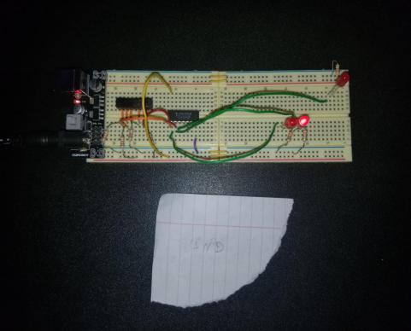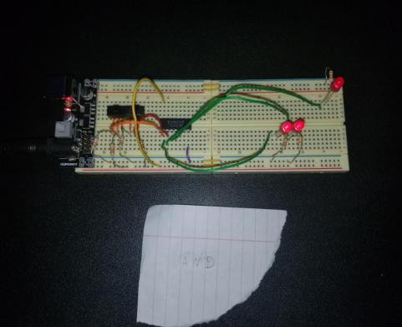

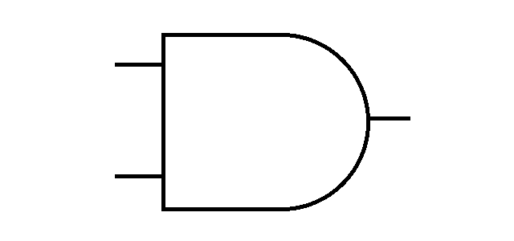

|  |  |  |
| --- | --- | --- |
| A | B | OUTPUT |
| 0 | 0 | 0 |
| 0 | 1 | 0 |
| 1 | 0 | 0 |
| 1 | 1 | 1 |

This is the circuit with the AND gate that has two switches with a 1k Ohms resistors connected to each and to ground, a power supply with 5v being used, two red LED’s connected to ground with two 330 Ohms resistors. A new LED is added for the output of the AND gate which only lit when both switches were High.

**OR Gate Circuit:**

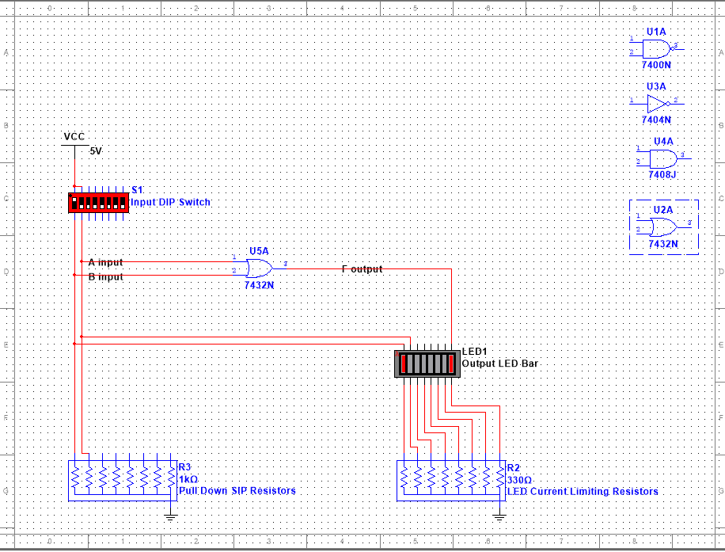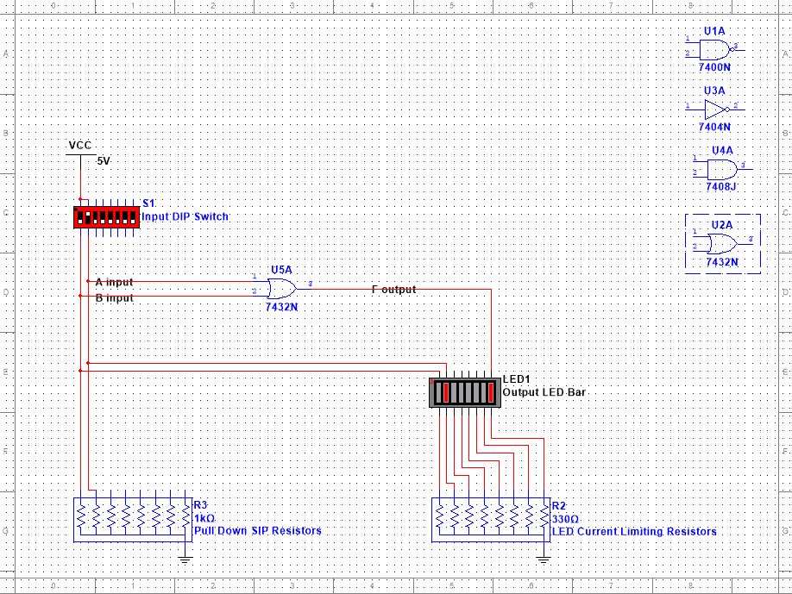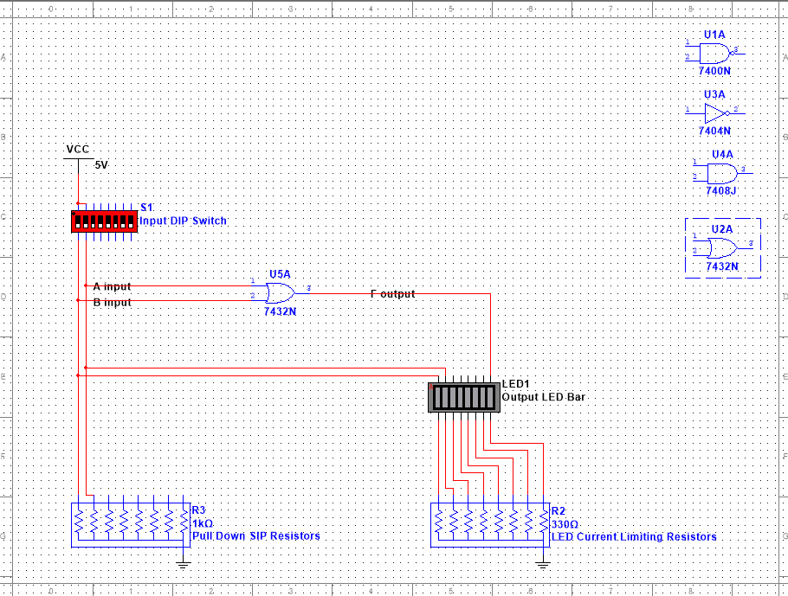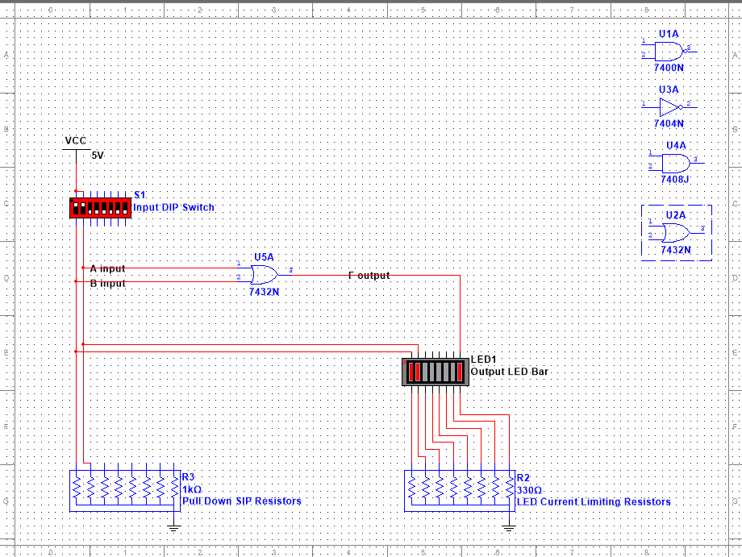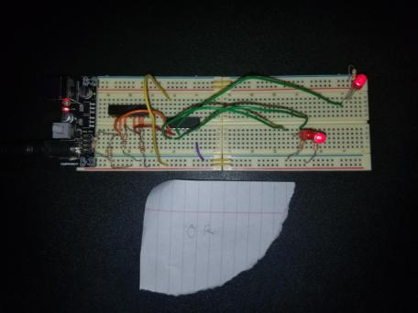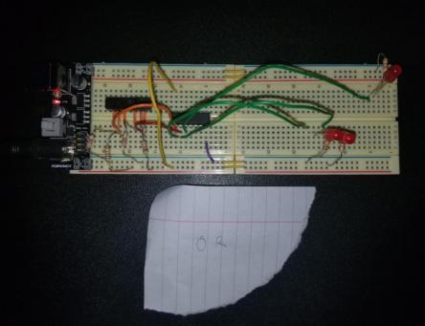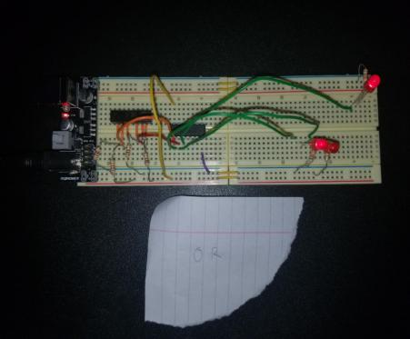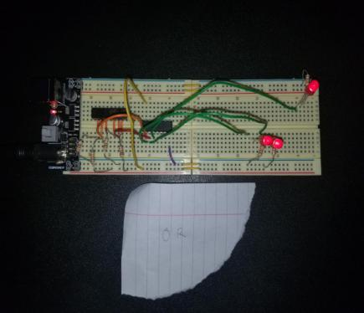

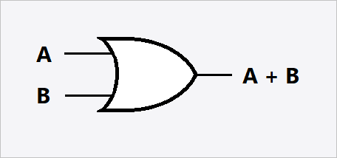

|  |  |  |
| --- | --- | --- |
| A | B | OUTPUT |
| 0 | 0 | 0 |
| 0 | 1 | 1 |
| 1 | 0 | 1 |
| 1 | 1 | 1 |

This is the circuit with the OR gate that has two switches with a 1k Ohms resistors connected to each and to ground, a power supply with 5v being used, two red LED’s connected to ground with two 330 Ohms resistors. A new LED is added for the output of the OR gate which lit for all the switch configurations except for the double Low output.

**NAND Gate Circuit:**

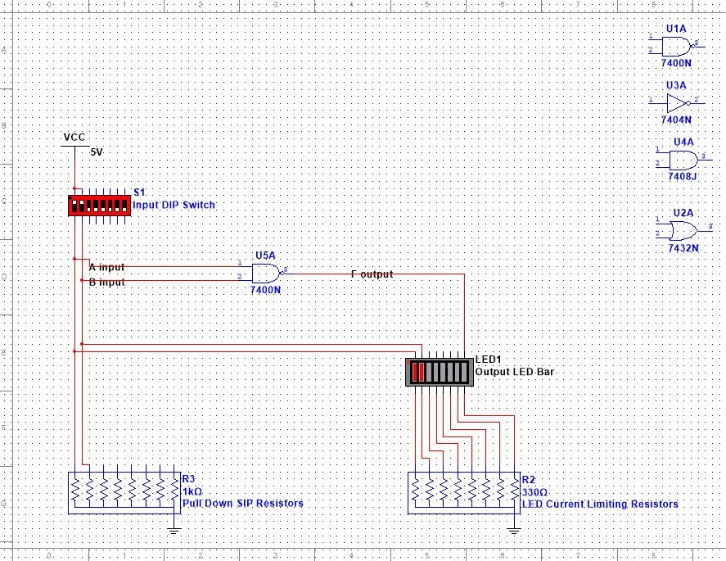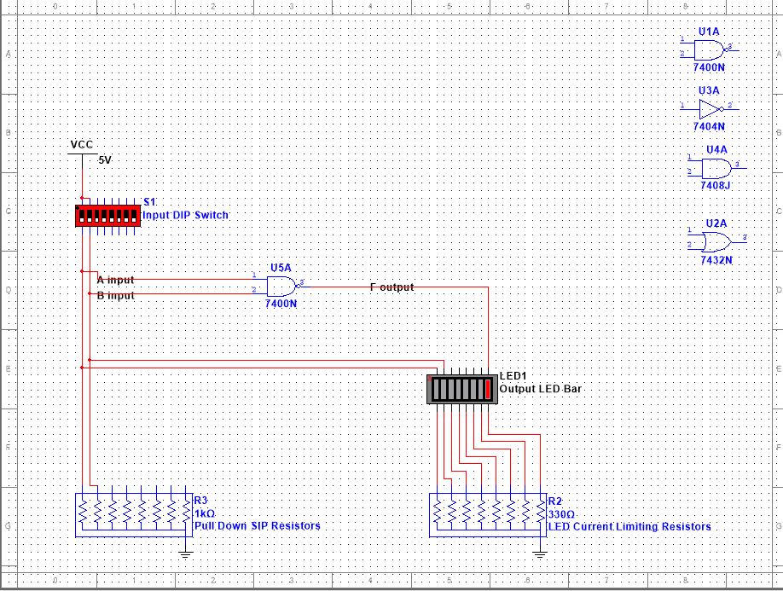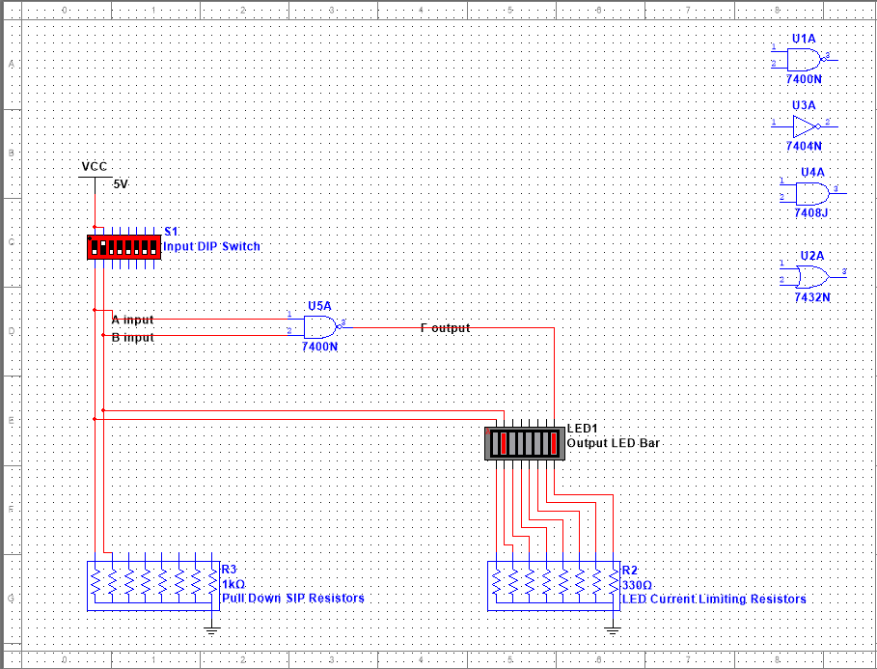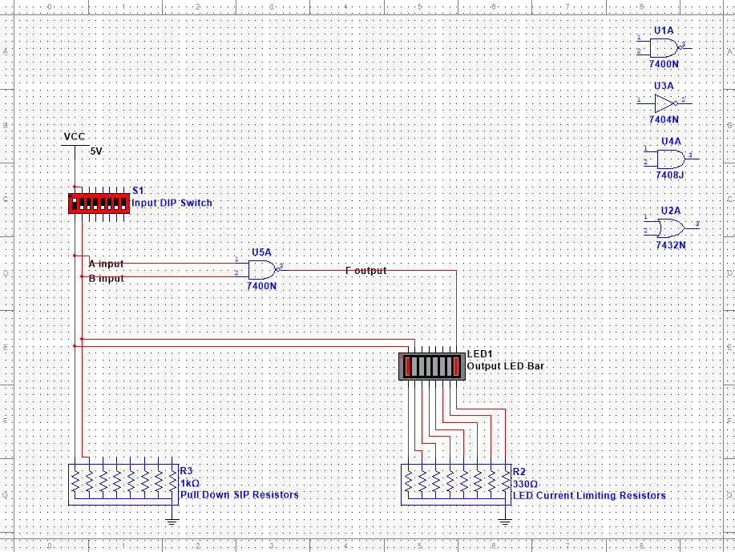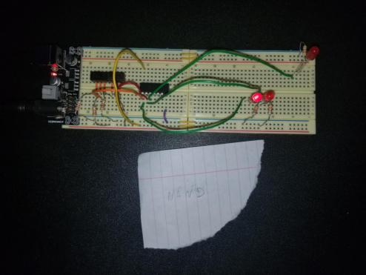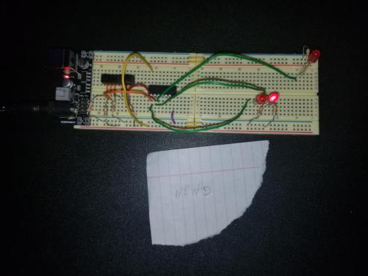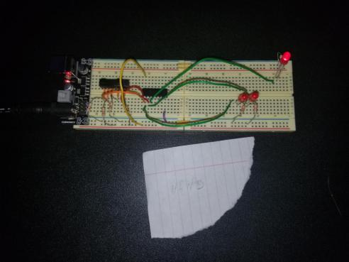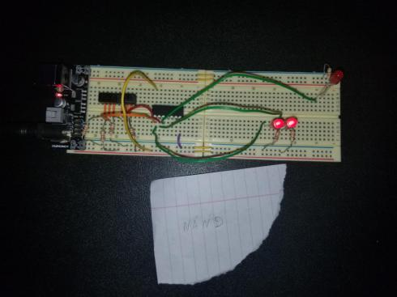

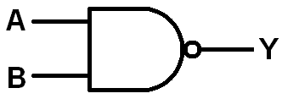

|  |  |  |
| --- | --- | --- |
| A | B | OUTPUT |
| 0 | 0 | 1 |
| 0 | 1 | 0 |
| 1 | 0 | 0 |
| 1 | 1 | 0 |

This is the circuit with the NAND gate that has two switches with a 1k Ohms resistors connected to each and to ground, a power supply with 5v being used, two red LED’s connected to ground with two 330 Ohms resistors. A new LED is added for the output of the NAND gate which lit for only the double Low switch configuration.

**INVERTER Gate Circuit:**

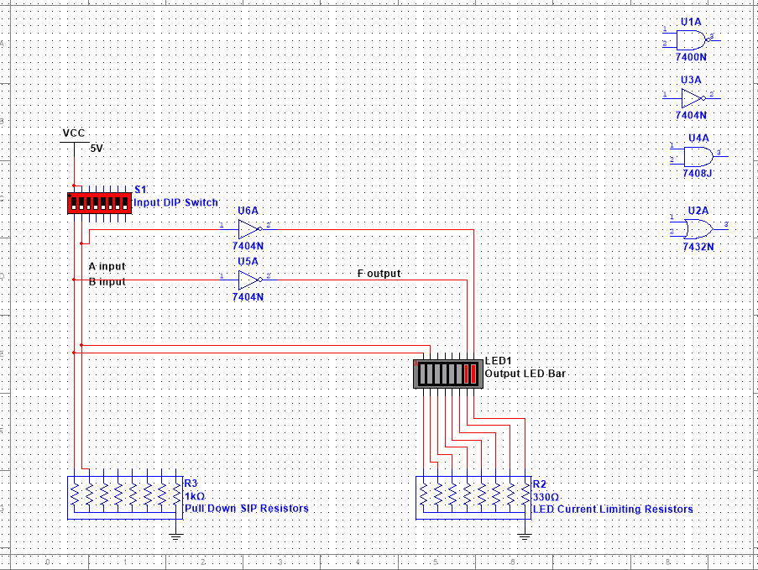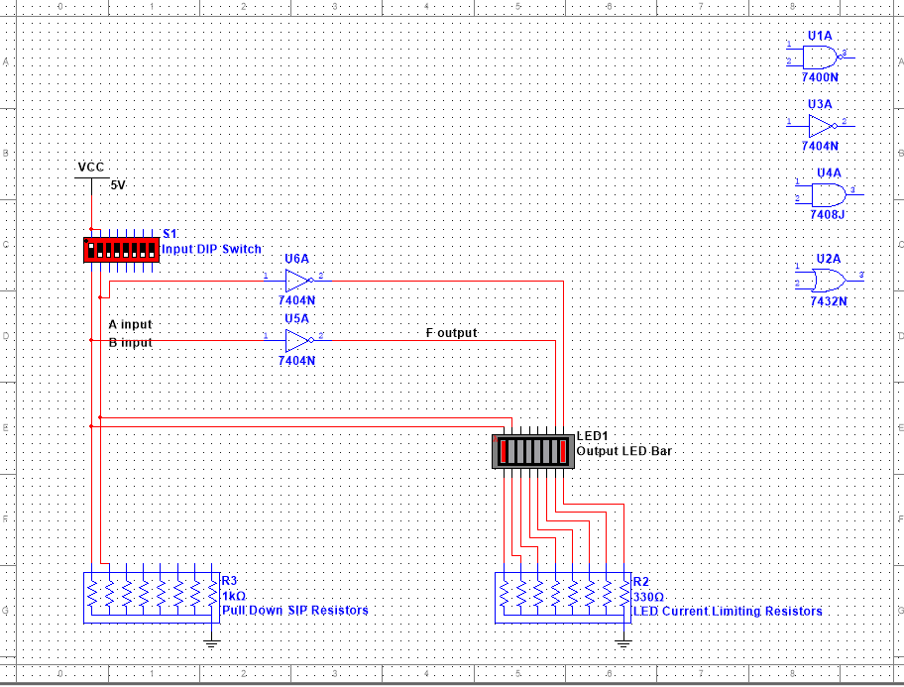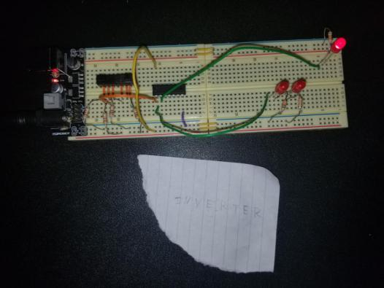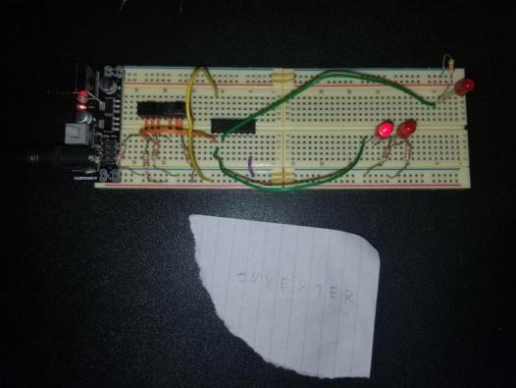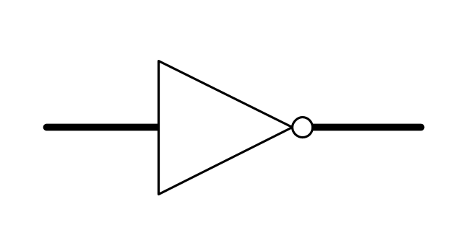

|  |  |
| --- | --- |
| A | OUTPUT |
| 0 | 1 |
| 1 | 0 |

This is the circuit with the INVERTER gate that has two switches with a 1k Ohms resistors connected to each and to ground, a power supply with 5v being used, two red LED’s connected to ground with two 330 Ohms resistors. A new LED is added for the output of the INVERTER gate which was only connected to one switch and would light the LED when the switch was Low and vice-versa.

**ALL-GATE Circuit:**

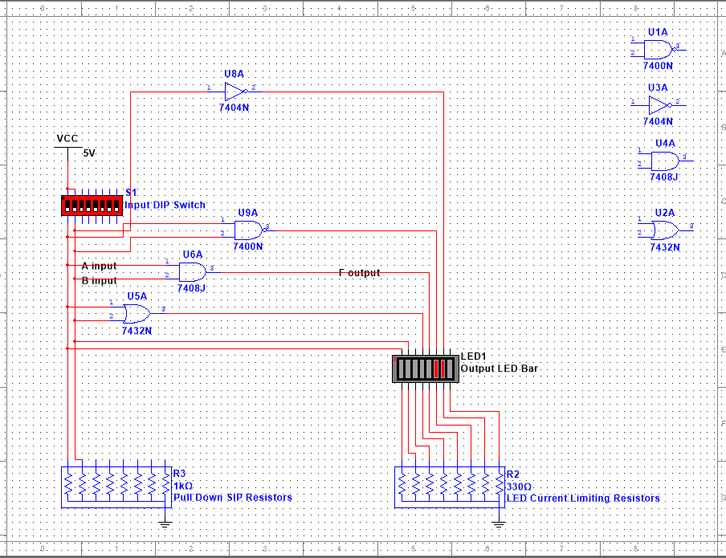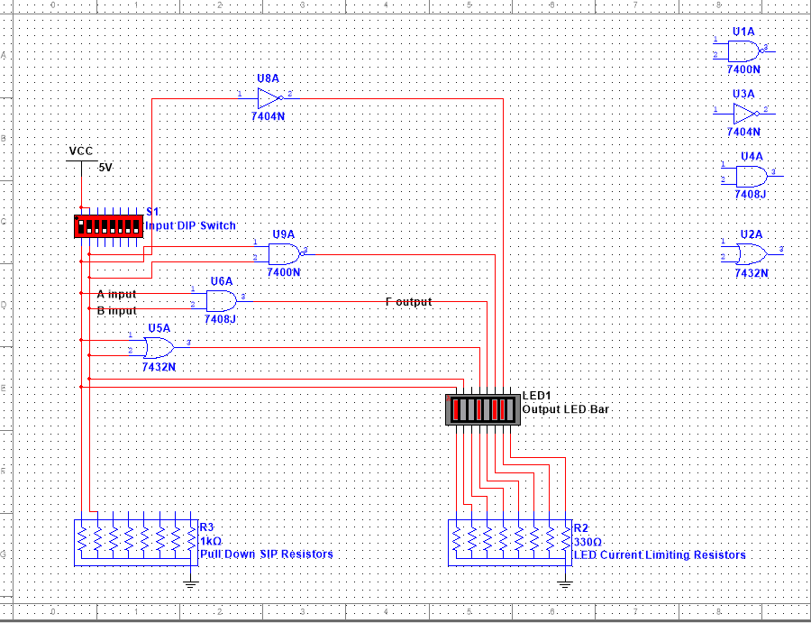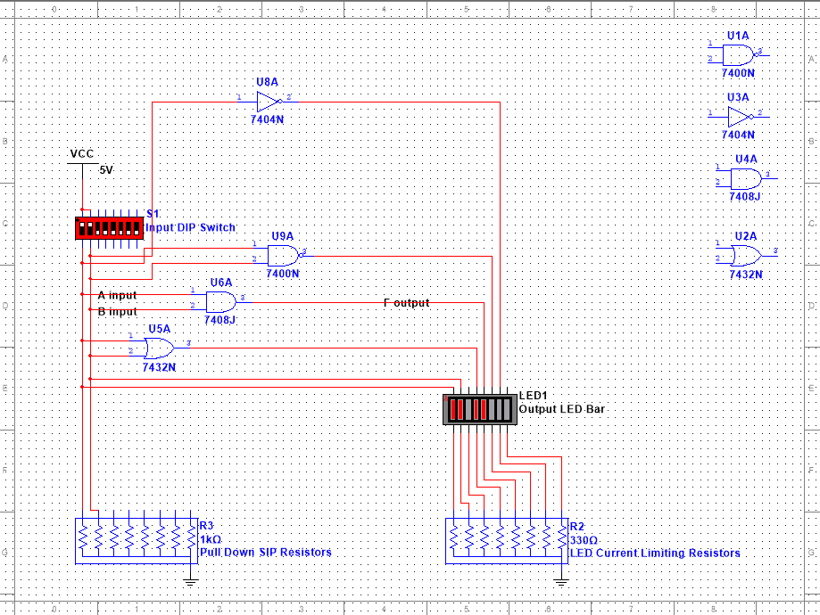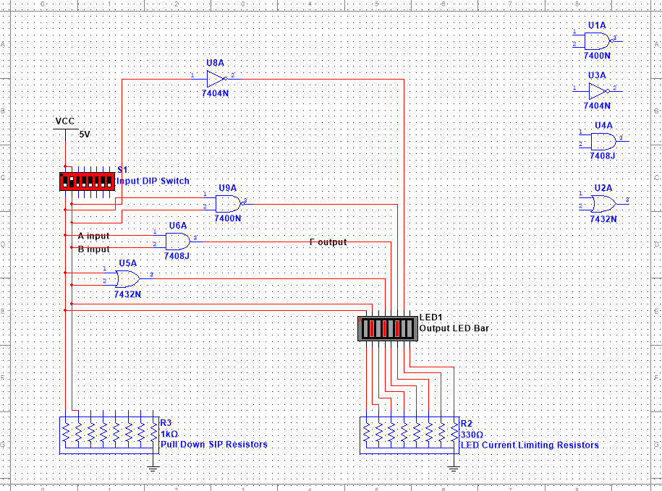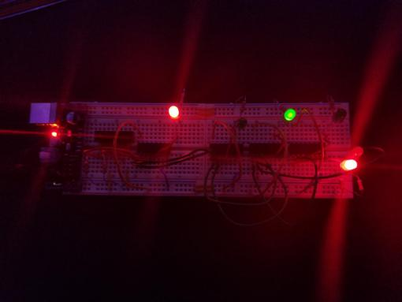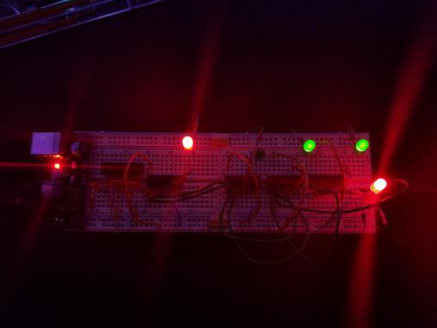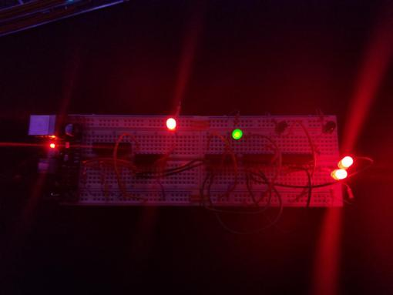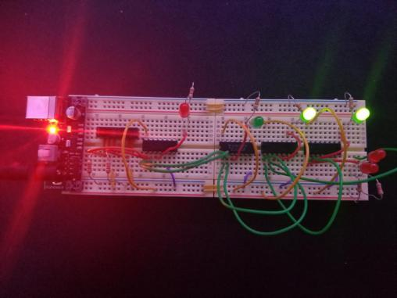

|  |  |  |  |  |  |  |  |  |  |  |  |  |  |
| --- | --- | --- | --- | --- | --- | --- | --- | --- | --- | --- | --- | --- | --- |
| INPUTS | | EXPECTED OUTPUTS (truth table) | | | | Multisim SIMULATED OUTPUTS | | | | Bread-Board OUTPUTS | | | |
| IN1 | IN2 | AND | OR | NAND | NOT | AND | OR | NAND | NOT | AND | OR | NAND | NOT |
| 0 | 0 | 0 | 0 | 1 | 1 | 0 | 0 | 1 | 1 | 0 | 0 | 1 | 1 |
| 0 | 1 | 0 | 1 | 1 | 1 | 0 | 1 | 1 | 1 | 0 | 1 | 1 | 1 |
| 1 | 0 | 0 | 1 | 1 | 0 | 0 | 1 | 1 | 0 | 0 | 1 | 1 | 0 |
| 1 | 1 | 1 | 1 | 0 | 0 | 1 | 1 | 0 | 0 | 1 | 1 | 0 | 0 |

This is the circuit with all the logic gates that has two switches with a 1k Ohms resistors connected to each and to ground, a power supply with 5v being used, two red LED’s used for the two switches and one red LED used for the OR gate. The OR gate was the first of the gates with a 330 Ohms resistor connected to its red LED and to ground. The next gate was the AND gate with a 330 Ohms resistor connected to its green LED and to ground. Next, was the NAND gate with a 330 ohms resistor connected to its green LED. Last, the INVERTER was connected to only one switch and to one green LED. The green LED was connected to ground with a 330 Ohms resistor.

Conclusion:

These labs were more difficult than the last; however, it was grand journey finally getting the circuit to work with every logic gate. Perseverance was key to finishing this multi-lab. I spent about 6 hours testing each gate and not stopping until everything worked as intended. Not having the DIP Switch, LED Bar, or the bar resistors made for a interesting detour on how to assemble the circuit. I learned a great deal about the logic gates and their incredible versatility. I have a better understanding of Multisim and getting the simulations to work. If I could tell my past self to make sure the switches are grounded and connected to the power source, this lab would have been completed immensely faster. In addition to, throwing out the big bread board sooner and using the two smaller bread boards connected by wires to keep the continuity across the board.